
MINISTRY OF HEALTH

Field Epidemiology and Laboratory Training Program
FIELD INVESTIGATION REPORT

Subject: Report on Hepatitis B Investigation in Baringo and Elgeyo Marakwet Counties, Kenya
February 2019

Contents
Background 3
1.1. Justification 5
1.2 Objectives 7
2.0 Methods 8
2.1. Study sites 8
2.2. Study period 10
2.3. Study Design 10
2.4. Study Population 10
2.4.1. Inclusion criteria 10
2.4.2. Exclusion criteria 10
2.5. Sample size calculation 10
2.6 Sampling technique 11
2.7. Laboratory Methods 13
2.8. Data collection 14
2.9. Data management 14
3.0 RESULTS 15
3.1 Jaundice Cases 15
3.1.1. Acute jaundice 15
3.2. Suspected Hepatitis B cases 15
3.2.1. Records review 15
3.2.2. Suspected cases from community, HCWs and Prisons 15
3.2.3. Review of screening and vaccination data 16
3.3. COMMUNITY SURVEY 16
3.3.1 Sociodemographic characteristics of house hold respondents 17
3.3.2. Socio-demographic characteristics of Hepatitis B positive cases 17
3.3.3. Clinical characteristics of Hepatitis B positive (HBsAg)cases 18
3.3.4. Behavioural characteristics of Hepatitis positive cases 19
3.4. Factors associated with Hepatitis B infection in the community 20
3.4.1. Bivariate analysis 20
3.4.2. Multivariate analysis 20
3.5. HEALTH CARE WORKERS SURVEY 22
3.5.1. Socio-demographic characteristics of health care workers 22
3.5.2. Sociodemographic characteristics of Hepatitis B positive (HBsAg) HCWs 23
3.5.3. Vaccination characteristics of Hepatitis B positive HCWs 24
3.5.4. Occupational exposure of HBsAg positive HCWs 24
3.6. PRISONS SURVEY 25
3.6.1. Socio-demographic characteristics of respondents in the prisons 25
3.6.2. Socio-demographic characteristics of hepatitis B positive case in the prisons 25
4.0. Community Knowledge, Attitudes and Practices towards Hepatitis B 27
4.1. Elgeyo-Marakwet County 27
4.1.1. Community Knowledge on Hepatitis B disease Elgeyo Marakwet 27
4.1.2. Community’s Attitude towards Hepatitis B infection 29
4.1.3. Community practices related to Hepatitis B disease 30
4.2. Baringo County 31
4.2.1. Community Knowledge, Attitude and Practice on Hepatitis B disease. 31
4.2.2. Community’s Attitude towards Hepatitis B infection 33
4.2.3. Community practices related to Hepatitis B 34
5.0. Conclusions 35
6.0. Recommendations 36
References 37

Background
Hepatitis B Virus (HBV) is classified in the family Hepadnaviridae genus Orthohepadnavirus, with eight genotypes but one serotype (Lok & McMahon, 2009). Hepatitis B is a viral infection spread through contact with infected blood or body-fluids during delivery or sexual intercourse, through sharing needles or use of same sharp objects like in mass traditional circumcision. Acute infection – with or without symptoms – may resolve spontaneously or undertake a chronic phase. Infants are more likely to develop chronic infections more than adults (CDC, 2015). The average incubation period is 90 days with a range of 60 to 150 days (CDC, 2015) although shorter incubation periods have been documented (Webster et al., 2000; WHO, 2017). Approximately 257 million people worldwide are living with HBV infection as evidenced by positive Hepatitis B Surface Antigen (HBsAg) test, and HBV contributed to the death of more than 880,000 people in 2015 (WHO, 2017). Kenya, as classified by the World Health Organization, is a highly endemic area with a prevalence of more than 8% {Franco, 2012 #72}. An overall HBsAg prevalence of 8.8% has been reported in an asymptomatic nomadic rural population in Kenya (Mutuma et al., 2011). The most recent studies reported variations in HBV prevalence as high as 13.3% among residents of informal urban settlements to 6% among HIV infected outpatient population while that among pregnant women was 9.4% (Kerubo et al., 2015). Another study established a prevalence of HBV is 5-30% among the general population and 9.4% among pregnant women (Ngaira et al., 2016). Other studies have shown that disparity exists in HBV infection prevalence by geographic area. One study found out the prevalence to be 8.8% in Turkana county which was the largest in the northwestern county in Kenya (Mutuma et al., 2011) and 11.2% in Eastern Kenya (Hyams et al., 1989). Other Studies of HBV infection prevalence in health-care settings yielded higher estimates may be due to selection bias. For example, a study by Pettigrew and others found that 77% of Kenyan patients at the liver clinic at the Kenyatta National Hospital in Nairobi, Kenya, who had chronic aggressive hepatitis or cirrhosis also had HBsAg positivity.(Mutuma et al., 2011). The most recent National survey by Kenya Demographic Health Survey (KDHS) indicates that, the HBV prevalence in Kenya is estimated at between 5 to 8% (Ly et al., 2016). According to a study on Prevalence of hepatitis B virus infection and uptake of hepatitis B vaccine among healthcare workers, Makueni County, Kenya 2017, the prevalence of HBsAg among HCWS was 4%, (Kisangau et al., 2018). No known published study in Kenya on prevalence of HBV among the innates in correctional facilities, however, according to a study done on HIV infection, viral hepatitis and liver fibrosis among prison inmates in West Africa found out that ,the HBV prevalence among the inmates was 12.5% (Jaquet et al., 2016)
The majority of people are unaware of their HBV infection, and therefore often present with advanced disease(Kerubo et al., 2015). Risk factors for HBV infection include male sex, history of HBV positive family member, non-vaccination, health-related occupation, multiple sexual partners, Intravenous Drug Use (IDU), history of hepatitis or blood transfusion and alcohol consumption. (Gheorghe, Csiki, Iacob, & Gheorghe, 2013; Lewis-Ximenez et al., 2002; Li et al., 2012; WHO, 2017). Signs and symptoms of HBV infection can include fever, fatigue, jaundice, joint pain, abdominal pain, loss of appetite, dark urine, nausea and vomiting (CDC, 2015; WHO, 2017). Risk for chronic infection decreases with age (CDC, 2015; D'souza & Foster, 2004; WHO, 2017).
During the acute phase of infection, immunoglobulin M (IgM) to the core antigen (anti-HBc IgM) will be detected and is a marker of high viral replication. Chronic infection is diagnosed by persistence of HBsAg for at least 6 months (WHO, 2017). Hepatitis B surface antibody (Anti-HBsAg) indicates immunity acquired by resolution of past infection or through immunization. The presence of Hepatitis B virus deoxyribonucleic acid (HBV DNA) indicates active viral replication and Hepatitis B e Antigen (HBeAg) correlates with HBV replication and infectivity but may be absent in patients with pre core or core mutations(MOH, 2013). There is no definitive treatment for acute infection; supportive care is indicated. Oral antivirals are used to slow disease progression in chronic infection (Lok & McMahon, 2009). Prevention is through Hepatitis B vaccination.

1.1. Justification
Baringo, Elgeyo Marakwet and West Pokot counties have reported an upsurge of reported cases of Hepatitis B.
Baringo County
Baringo County reported an upsurge of Hepatitis B and the Department of Health has been conducting routine screening and testing for general population, in the community and health care workers at the county hospitals and sub-county hospitals and additional select health centres and dispensaries. (Table 1). In January 2018, 27/243 (11.1%) screened tested positive for Hepatitis B surface antigen (HBsAg using DiaSpot Rapid Diagnostic Test kit). In October 2018 HBsAg positivity rate in Baringo North was 7.8%. Samples from those who were HBsAg positive were referred for Polymerase Chain Reaction (PCR) testing at Kenya Medical Research Institute (KEMRI) Centre for virology research. (Table 2).
Table 1: Hepatitis B Screening using HBsAg and Vaccination by sub-county, Baringo County, 2016-2018
Sub-County | Period | No. tested | No. positive | Positivity rate (%) | No negative | HCW Vaccinated | Total vaccinated
Baringo Central | 2016-2018 | 2391 | 159 | 6.6 | 2232 | 597 | 1787
Mogotio | 2018 | 1482 | 38 | 2.6 | 1439 | 0 | 1439
Baringo South | 2014-2018 | 815 | 102 | 12.5 | 715 | 0 | 703
Baringo North | 2016 | 728 | 53 | 7.3 | 671 | 39 | 678
Koibatek | 2017-2018 | 167 | 22 | 13.2 | 153 | 0 | 371
Tiaty | 0 | 0 | 0 |  | 0 | 0 | 0
Total |  | 5583 | 374 | 6.7 | 5210 | 636 | 4978
(Source: Baringo County Surveillance Report, 2018)
Table 2: Results of Hepatitis B Screening using HBsAg, vaccination Baringo North Sub County, October 2018.
Venue | Date | Total tested | Positive | Positivity rate (%)
Kuikui | 2/10/2018 | 36 | 4(M-2 F-2) | 11.1
 | 3/10/2018 | 101 | 8(M-5 F-3) | 7.9
Chemintany | 2/10/2018 | 134 | 17(M-12 F-5) | 12.7
 | 3/10/2018 | 266 | 13(M-6 F-7) | 4.9
Total |  | 537 | 42(7.8%) | 7.8
(Source: Baringo County Surveillance Report, 2018)
Elgeyo Marakwet County
Since 2017, at least 6 deaths from 4 Sub-counties (Keiyo North, Keiyo South, Keiyo East and Marakwet West) have been reported and were suspected to be due to Hepatitis B infection. The index case was a 43-year-old male nurse working at Tambach Sub-county Hospital who died while undergoing treatment for Hepatitis B. In Keiyo South in 2017, 2/160 (1.3%) screened tested positive. In 2018, 7 people from Marakwet West Sub-county were reported to have tested Hepatitis B positive by Rapid Diagnostic Test (RDT). From May through September 2018, 519 people were screened and 5 (1%) tested positive for Hepatitis B. Those with negative tests received 1st dose of Hepatitis B vaccine.
West Pokot County
By November 2018, 33/295 (11.2%) had tested positive for HBsAg using Diaspot RDT. As at November 2018,twenty three of them were from GK Prison and six of them were from Kompass village in Pokot North. Out of those who had positive screening test results, 10 (30.3%) were confirmed by the reference laboratory. Hepatitis A and C testing was negative. Out of the 14 samples referred to the National Public Health Laboratory (NPHL), 10 (71.4%) were positive. The county awaits confirmatory results of the other 23 individuals. The county is currently vaccinating health care workers. Out of the targeted 1344, 863 (64.2%) have received at least 1 vaccine dose.
Table 3: Results of Hepatitis B Screening by Sub-county, West Pokot, 2018
Sub county | Village | Pop(estimates) | Number screened | Number Positive | Percentage (%)
Pokot North | Chemworor | 225 | 47 | 0 | 0
 | Shongen | 300 | 165 | 4 | 2.2
 | Kompass | 260 | 48 | 6 | 12.3
Pokot South | Lomuke | 256 | 35 | 0 | 0
West Pokot | Gk Prison | 540 | 539 | 23 | 4.3
 | Total | 1041 | 834 | 33 | 3.7

The Ministry of Health intends to dispatch a team of Disease Surveillance and Response Unit (DSRU) officers backed up by their Field Epidemiology and Laboratory Training Program (FELTP) colleagues to support the counties in conducting a sero-prevalence survey in-order to establish the prevalence of HBV infection, the associated risk factors in this communities and knowledge of, attitude and practices towards HBV infection. This will help improve prevention and response strategies for apparently high prevalence of HBV in these areas or populations.

1.2 Objectives
- To characterize acute jaundice, suspected and confirmed HBV cases in Baringo and Elgeyo Marakwet counties
- To estimate the prevalence of chronic HBV infection among general population adults, health care workers and prisoners in Baringo and Elgeyo-Marakwet counties
- To describe factors associated with chronic HBV infection in Baringo and Elgeyo-Marakwet counties
- To assess the knowledge, attitude and practices (KAP) towards HBV in Baringo and Elgeyo- Marakwet counties

2.0 Methods

2.1. Study sites
The three counties border each other and are located in the Northern Rift region. They all fall within Arid and Semi-Arid Lands (ASAL) with poor physical infrastructure, inhabited by highland and plain nilotes and main economic activities are livestock rearing and subsistence crop farming.
Baringo County covers an area of 11075 km² and has a projected population of 754,014 and is made up of 6 sub-counties namely: Baringo North, Baringo South, Baringo Central, Mogotio, Tiaty and Eldama Ravine. The main economic activity is dairy farming and agriculture.
Elgeyo Marakwet has a projected population of 401989 as at 2012 and covers 3030km2 of land area. It is made up of four sub-counties: Marakwet East, Marakwet West, Keiyo North and Keiyo South. The main economic activities are mixed farming, tourism and fluorspar mining.
West Pokot County has a projected population of 664,035 and an approximate area of 8,400 km². The County is made up of four sub-counties namely; Pokot South, Central, West and North Pokot. Agriculture is the main economic activity; cattle, goats and sheep are a major source of revenue.
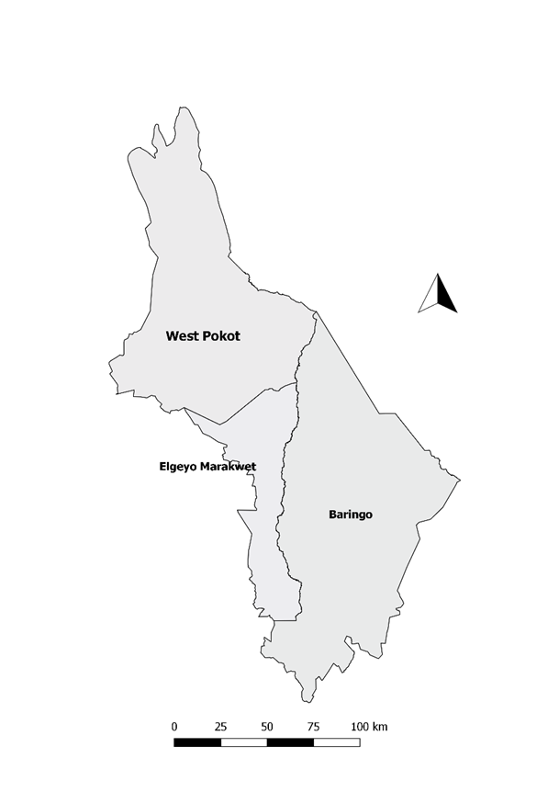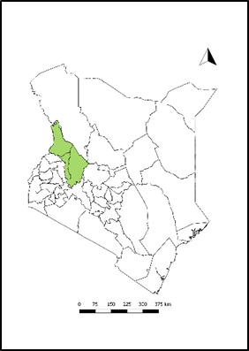
Figure 1: Baringo, West Pokot and West Pokot Counties

2.2. Study period
The study was carried out in February 2019

2.3. Study Design
This was a cross sectional study.

2.4. Study Population
The study was conducted among community members, healthcare workers and prisoners.
2.4.1. Inclusion criteria
Any adult member of a household, HCW or prisoner who has been randomly selected.

2.4.2. Exclusion criteria
Members aged below 18 years, before random selection at the household level.

2.5. Sample size calculation
Community
Sample size estimation was done using Cochran’s formula (1977) and the average prevalence of HBsAg as 8.8% {Mutuma, 2011 #73} and a design effect of 2.
Sample size, n= 2*Z²p (1-p)/d²
The following assumptions were made for the calculation
Z=standard normal deviate for 95% confidence interval (=1.96)
p=estimated prevalence of hepatitis B among the rural nomadic community (8.8 %)
d=Degree of precision (5%)
Adjustment by 10% for incomplete or non-response
Minimum sample size was 272 households per county.

Healthcare workers (HCW)
Sample size estimation was done using Cochran’s formula 1977 and the average prevalence of HBsAg as 4.5% {Kisangau, 2018 #71}.
Sample size, n= Z²p (1-p)/d²
The following assumptions were made for the calculation
Z=standard normal deviate for 95% confidence interval (=1.96)
p=estimated prevalence of hepatitis B among the health care workers (4.5 %)
d=Degree of precision (5%)
Adjustment by 10% for incomplete or non-response
Minimum sample size was 74 HCW per county.
Prisoners
Sample size estimation was done using Cochran’s formula 1977 and the average prevalence of HBsAg as 4.8% {Dolan, 2016 #70}.
Sample size, n= Z²p (1-p)/d²
The following assumptions were made for the calculation
Z=standard normal deviate for 95% confidence interval (=1.96)
p=estimated prevalence of hepatitis B among prisoners (4.8 %)
d=Degree of precision (5%)
Adjustment by 10% for incomplete or non-response
Minimum sample size was 78 prisoners per county.

2.6 Sampling technique
Community survey
We conducted multi-stage cluster sampling. We conducted the survey in Baringo South, Baringo North and Mogotio sub-counties in Baringo County and Keiyo South and Marakwet West sub counties in Elgeyo-Marakwet. All the wards within the selected sub counties will be selected. The sample size will be distributed proportionate to size in the wards within the sub-county (Table 4 & 5). At the ward level, we will obtain a list of villages and estimated number of households per village. A random number table will be used to select the villages to be sampled. Using the randomly selected villages we will further divide the sample size for that ward proportionate to number of households. At the major village landmark, a bottle will be spun and the team will begin the survey in the household that is pointed and afterward proceed to every k^{th} house based on sample size divided by the number of households. At the selected household, consent will be sought from the head and the questionnaire will be administered to one adult selected randomly. A blood sample was collected at the end of the interview. At the end, the interviewer will educate the family members on causes, risk factors, prevention and control of Hepatitis B.

Table 4: Proportionate to Size Sampling, Baringo County, 2019
Sub County | Ward | Population | Number  of Households | Sampled households
Baringo North | Bartabwa | 29026 | 5805 | 16
 | Barwessa | 85523 | 17105 | 47
 | Kabartonjo | 72421 | 14484 | 40
 | Saimosoi | 9424 | 1885 | 5
 | Saimokipsaraman | 32121 | 6424 | 18
Mogotio | Emining | 47699 | 9540 | 26
 | Kisanana | 55004 | 11001 | 30
 | Mogotio | 62765 | 12553 | 35
Marigat | Mukutany |  | 4965 | 14
 | Muchongoi |  | 4965 | 14
 | Marigat |  | 4965 | 14
 | Ilchamus |  | 4965 | 14
 | Total |  | 98657 | 272
Source: DHIS

Table 5: Proportionate to Size Sampling, Elgeyo Marakwet County, 2019
County | Sub county | Ward | Population | Number Households | Sampled Households
Elgeyo Marakwet | Keiyo South | Chepkaria | 85217 | 5867 | 27
 |  | Kabiemit | 18650 | 3730 | 17
 |  | Kaptarakwa | 21272 | 4255 | 20
 |  | Metkei | 20230 | 4045 | 19
 |  | Soy North | 29733 | 5947 | 28
 |  | Soy South | 24050 | 4809 | 22
 | Marakwet West | Arror | 19728 | 3945 | 18
 |  | Cherangany | 49263 | 4988 | 23
 |  | Kapsowar | 26814 | 5363 | 25
 |  | Lelan | 33608 | 2954 | 14
 |  | Moiben Kuserwo | 63837 | 6268 | 29
 |  | Sengwer | 68900 | 6425 | 30
 |  |  | 461302 | 58596 | 272
Source: DHIS 2
Healthcare worker survey
We sampled healthcare workers based in the facilities in the selected sub-county. The sample size was distributed proportionate to size based on staffing levels. A healthcare worker was defined as an individual who works in a health facility providing healthcare services or involved in maintenance of the health facilities.
Prisoners’ survey
We recruited participants from the prison located within the county. The sample size was distributed proportionate to size in the different prison holding areas. We randomly sampled the prisoners using a random number table and register maintained by the administration.
Retrospective review of records and updating the line-list
We conducted retrospective review of records from January 2016 to December 2018 and used the following case definitions: a suspected case was defined as jaundice or elevated alanine aminotransferases (>200IU/L), a probable case was one who met the suspected case definition and epidemiologically linked to a confirmed case and a confirmed was a case with laboratory detection of HBsAg or isolation of the virus in blood through Polymerase Chain Reaction (PCR).
The teams conducted active case search by reviewing hospital, outpatient and vaccination campaign records in health facilities to identify suspected cases. The case definition for active case search was: an entry of patient with jaundice or elevated Liver Function Tests (LFTs). New cases who presented to the health facility during the investigation period were interviewed to identify possible exposures and laboratory testing conducted.
Key informant interview
We interviewed the County Director of Health, County Disease Surveillance Coordinators and Sub-county Medical Officers of Health to obtain more information on surveillance and control activities for Hepatitis B in the county.

2.7. Laboratory Methods
Blood sample was collected from the identified household member, HCW or prisoner for HBV testing. Approximately 3 - 4ml of whole blood was collected. The samples were stored under cold chain of 2 – 8⁰ C. The samples were centrifuged at the nearest identified laboratory with centrifuge on the same day. Plasma was harvested and rapid test screening for antibodies to HBsAg conducted. The plasma was stored in a separate red top cryovial under cold chain and packaged for transport to reference lab where testing for total anti-HBc) was to be done. The ACON® Enzyme Immuno Assay test kit for anti-HBc will be used. We used one laboratory per sub-county/county to run the rapid tests daily and for storage of the samples. Standard Operating Procedures (SOPs) were clearly displayed on the wall and a qualified laboratory officer was engaged to assist in the testing. Quality control was done by random repeat testing of one-third of the samples by a second laboratory officer. Results of these tests were relayed back to the participants through the County and Sub-county Disease Surveillance Co-ordinator. Those who tested positive were to be counselled and linked to care at the facility level. Mass vaccination is not recommended. Vaccination is recommended for health care workers, prisoners, injective drug users, those who receive frequent blood transfusion and household contacts of the positive cases.

2.8. Data collection
A structured standardized questionnaire was used for face to face interview. Laboratory request forms were used for sample collection and had the same identifying information as that of the questionnaire used to enable linking of test results to individuals. Variables collected included: identifying information, demographic information, information on risk factors, knowledge attitude and practices towards HBV infection and serological tests results. The questionnaire was written in English and translated into Swahili.

2.9. Data management
Data was entered, cleaned and analysed using Microsoft Excel software (Microsoft Office, Seattle, USA) and Epi info 7.2 software. Analysis was conducted to examine social demographic characteristics of participants, prevalence rate of acute and chronic infection, risk factors, knowledge, attitude and practices towards HBV infection among the study population. Descriptive statistics was performed. Means and medians were calculated for continuous variables and proportions/ frequency for categorical variables. Odds ratios (ORs) at 95% confidence interval (CI) were calculated to test the statistical significance of the risk factors to the infection, those with p-values of ≤0.2 were considered statistically significant. They were subjected to multivariate analysis and variables with p-value of less than 0.05 were considered to be independently associated with the disease outcome.

3.0 RESULTS

3.1 Jaundice Cases

3.1.1. Acute jaundice
No active acute jaundice cases were found during the survey.

3.2. Suspected Hepatitis B cases
During retrospective data review and questionnaire administration, the teams identified record/persons with jaundice.

3.2.1. Records review
Records review in Elgeyo-Marakwet identified 58 cases of jaundice but laboratory results were not available in the records. Their mean age was 38 years (±25), males were 34(58.6%) and age group ≥60 years had the highest number of jaundice cases 14/58 (24.1%).
Table 6: Demographic characteristics of suspected Hepatitis B cases in Elgeyo-Marakwet County, Kenya, 2019
Demographics | Frequency | %
Sex
Male | 34 | 58.6
Female | 24 | 41.4
Age
0-9 | 6 | 10.3
10-19 | 11 | 19.0
20-29 | 11 | 19.0
30-39 | 7 | 12.1
40-49 | 2 | 3.4
50-59 | 7 | 12.1
≥60 | 14 | 24.1

3.2.2. Suspected cases from community, HCWs and Prisons
During interviews 16/546 (2.9%) from the community and 13/157(8.3%) from prisons reported history of jaundice of this 4/16(25%) and 3/13(23.1%) tested positive for HBsAg respectively.

Table8: Number of suspected Hepatitis B cases among health care workers, community members and those living within prisons, Baringo and Elgeyo-Marakwet Counties, Kenya, 2019
 | Had Jaundice  Frequency (%) | Tested positive for HBsAg  Frequency (%)
Community | 16/546 (2.9) | 4/16 (25)
Health care workers | 0 | 0
Prisons | 13/157 (8.3) | 3/13 (23.1)

3.2.3. Review of screening and vaccination data
A total of 13,415 people were screened for HBsAg. Keiyo North Sub County had the highest number of positive cases 188/5071 (3.7%). A total of 9,327 received first dose of hepatitis b vaccination. Keiyo North had the highest number of people vaccinated 9327/17,483 (53.3%).
Table 7: Distribution of Hepatitis B screening and positivity rates by Sub Counties, Elgeyo Marakwet County, Kenya, 2019.
Sub County | No. people screened for HBsAg | No. positive (HBsAg) | Positivity rate | No. of people vaccinated (1st Dose)
Keiyo North | 5071 | 188 | 3.7 | 9327
Keiyo South | 2804 | 58 | 2.1 | 2707
Marakwet East | 1622 | 17 | 1.0 | 1605
Marakwet West | 3918 | 51 | 1.3 | 3844
Total | 13,415 | 314 | 2.3 | 17,483

3.3. COMMUNITY SURVEY
The teams visited and conducted interviews in 546 households (272 Baringo and 274 Elgeyo-Marakwet), 542(99.3%) provided blood samples for HBsAg testing. Among those tested 41 (7.6%) were positive for HBsAg, of the positives 35 (85.4%) were from Baringo and 6(14.6%) Elgeyo-Marakwet.

3.3.1 Socio-demographic characteristics of house hold respondents
The average age of the respondents was 42 years (SD 15years). Majority were female 314(57.5%) and the age group of 25-34 had most respondents. Most of the respondents were married 44(781.9%) and 418(76.6%) had formal education.
Table: Sociodemographic characteristics of house hold respondents in Baringo and Elgeyo-Marakwet Counties, Kenya 2019.
Characteristic | Frequency (%)
Sex  Female  Male | 314(57.5)  232(42.5)
Age group  <25  25-34  35-44  45-54  ≥55 | 66(12.1)  134(24.5)  125(22.9)  98(18.0)  123(22.5)
Marital status  Married  Single  Separated  Divorced  Widowed  Not documented | 447(81.9)  72(13.2)  8(1.5)  1(0.2)  15(2.8)  3(0.6)
Formal education  Yes  No  Not documented | 418(76.6)  70(12.8)  58(10.6)
Religion  Christianity  Islam  None | 522(95.8)  1(0.2)  23(4.0)

3.3.2. Socio-demographic characteristics of Hepatitis B positive cases
Majority of the positive cases were men 25(71.4%) in Baringo and 4(66.7%) in Elgeyo-Marakwet. Most were in the age group (25-35) in Baringo while those in Elgeyo-Marakwet were between the ages (25-54). All the cases 6(100%) were married in Elgeyo-Marakwet while more than half were married 31(88.6%) in Baringo.
Table: Socio-demographic characteristics of Hepatitis B positive (HBsAg) cases in the general population in Baringo and Elgeyo-Marakwet Counties, Kenya, 2019.
Characteristic |  | Baringo n= 35  Frequency (%) |  | Elgeyo Marakwet n=6  Frequency (%)
 | Sex  Female  Male |  | 10 (28.6)  25 (71.4) |  | 2 (33.3)  4 (66.7)
 | Age group  <25  25-34  35-44  45-54  ≥55 |  | 6((17.1)  9(25.7)  6(17.1)  6(17.1)  8(22.9) |  | 0 (0.0)  2(33.3)  2(33.3)  2(33.3)  0(0.0)
 | Marital status  Married  Single  Separated |  | 31(88.6  3(8.6)  1(2.9) |  | 6(100)  0(0.0)  0(0.0)
 | Formal education  Yes  No  Missing |  | 26(74.3)  5(14.3)  4(11 |  | 6(100)  0(0.0)  0(0.0)
 | Religion  Christianity  Islam  None |  | 34(97.1)  0(00.0)  1(2.9) |  | 6(100)  0 (0.0)  0 (0.0)

3.3.3. Clinical characteristics of Hepatitis B positive (HBsAg) cases
In the previous six months before the survey the number of hepatitis B positive cases from Baringo who reported to have had jaundice was 4 (11.4%) and those who reported to have had dark urine were 9 (25.7%). while Elgeyo-Marakwet had none. All 6(17.1%) who knew their Hepatitis B status before the survey were from Baringo. Of the cases only 4(11.4%) from Baringo were on treatment while none was on treatment from Elgeyo-Marakwet. None of the Hepatitis B positive cases were HIV positive.
Table: Clinical characteristics of Hepatitis B positive (HBsAg) cases in the general population in Baringo and Elgeyo-Marakwet Counties, Kenya, 2019.
Characteristic |  | Baringo (n=35)  Frequency (%) |  | Elgeyo Marakwet (n=6)  Frequency (%)
Signs and symptoms
 | Fever |  | 5(14.3) |  | 0(0.0)
 | Fatigue |  | 5(14.3 |  | 1(16.7)
 | Loss of appetite |  | 4(11.4) |  | 0(0.0)
 | Nausea |  | 4(11.4) |  | 0(0.0)
 | Abdominal pains |  | 14(40) |  | 0(0.0)
 | Joint pains |  | 14(40) |  | 1(16.7)
 | Dark urine |  | 9(25.7) |  | 0(0.0)
 | Grey coloured stool |  | 1(2.9) |  | 0(0.0)
 | Jaundice |  | 4(11.4) |  | 0(0.0)
 | Knew their Hepatitis B status before survey
 | Yes |  | 6(17.1) |  | 0(0.0)
 | HIV status
 | Positive |  | 0(0.0) |  | 0(0.0)
 | Negative |  | 19(54.3) |  | 5(83.3)
 | Don’t know |  | 16(45.7) |  | 1(16.7)
 | Sought medical attention in past 6 months
 | Yes |  | 14(40) |  | 1(16.7)
 | No |  | 18(51.4) |  | 5(83.3)
Not documented |  | 3(8.6) |  | 0(0.0)

3.3.4. Behavioural characteristics of Hepatitis positive cases
Less than half of the positive cases 10(28.6%) from Baringo and 1(16.7%) from Elgeyo-Marakwet drank alcohol. Those who had <2 sexual partners in the last six months were 24(70.6%) in Baringo and 5(83.3%) in Elgeyo-Marakwet.
Table: Behavioural characteristics of Hepatitis B positive (HBsAg) cases in the general population in Baringo and Elgeyo-Marakwet Counties, Kenya, 2019.
Characteristic | Baringo  Frequency (%) | Elgeyo-Marakwet  Frequency (%)
Alcohol use  Yes | 10 (28.6) | 1 (16.7)
Number of sexual partners in the last 12 months  <2  ≥2 | 24(70.6)  10 (29.4) | 5(83.3)  1(16.7)
Unprotected sex  Yes | 6(17.1) | 2(33.3)

3.4. Factors associated with Hepatitis B infection in the community

3.4.1. Bivariate analysis
Participants of male gender had approximately four times (OR 3.5; CI 1.7-7.1) the odds of having hepatitis B infection compared to female participants. Those circumcised had three times the odds (OR 2.8; CI 1.35-5.8) of having Hepatitis B compared to the uncircumcised participants. Participants who shaved in the barbershop had four times the odds (OR 4.1; CI 1.9-8.7) of having hepatitis B compared to those not shaving in the barbershop.

3.4.2. Multivariate analysis
On multivariate analysis having multiple sexual partners (aOR 2.5; CI 1.1-5.8) and shaving in a barbershop (aOR 2.7; CI 1.1-7.0) were factors independently associated with Hepatitis infection.

Table: Bivariate and multivariate analysis of factors associated with Hepatitis B infection among the general population in Baringo and Elgeyo-Marakwet Counties, Kenya, 2019
Characteristics | Positive  n=41 | Negative  n=501 | uOR 95% CI | aOR 95% CI
Sex
Female | 12(29.3) | 298(59.5) | Ref
Male | 29(70.3) | 203(40.5) | 3.5 (1.7-7.1) | 2.0(0.6-6.8)
Age group
<25 | 6(14.6) | 60(112.0) | Ref
25-34 | 11(26.8) | 123(24.6) | 0.9 (0.3-2.5)
35-44 | 8(19.5) | 113(22.6) | 0.7 (0.2-2.1)
45-54 | 8(19.5) | 90(18.0) | 0.9 (0.3-2.7)
≥55 | 8(19.5) | 115(23.0) | 0.7(0.2-2.1)
Marital status
Never married | 3(7.3) | 68(13.6) | Ref
Ever married | 38(92.7) | 433(86.4) | 2.2 (0.6-6.6)
Type of marriage (n=474)
Monogamous | 24(63.2) | 328(75.7) | Ref
Polygamous | 14(36.8) | 105(24.3) | 1.8 (0.9-3.6)
Formal education
Not documented | 4(9.8) | 3(0.6) | Ref
Yes | 32(78.1) | 458(91.4) | 0.1(0.0-0.2)
No | 5(12.2) | 40(8.0) | 0.1(0.0-0.5)
Having Circumcised
No | 10(24.1) | 237(47.3) | Ref
Yes | 31(75.6) | 264(52.7) | 2.8 (1.3-5.8) | 1.0(0.3-3.4)
Currently living with sexual partner
No | 5(12.2) | 128(25.6) | Ref
Yes | 36(87.8) | 373(74.5) | 2.5(0.9-6.40
Number of sexual partners in last 12 months
<2 | 29(72.5) | 420(88.4) | Ref
≥2 | 11(27.5) | 55(11.6) | 2.8 (1.4-6.1) | 2.5 (1.1-5.8)
Living with someone diagnosed with HBV
No | 34(82.9) | 461(92.0) | Ref
Yes | 5(12.2) | 18(3.6) | 3.8(1.3-10.8) | 2.4(0.7-7.7)
Don’t Know | 2(4.9) | 22(4.3) | 1.2(0.3-5.5) | 3.4(0.6-17.4)
Having a member who died of HBV
No | 36(87.8) | 469(93.6) | Ref
Yes | 2(4.9) | 6(1.2) | 4.3(0.8-22.3)
Don’t Know | 3(7.3) | 26(5.2) | 1.5(0.4-5.2)
Having shared tooth brush/twigs
No | 35(85.4) | 479(95.6) | Ref
Yes | 1(2.4) | 9(1.8) | 1.5(0.2-12.3) | 1.0(0.4-2.3)
Missing | 5(12.2) | 13(2.6) | 5.3(1.8-15.6) | 0.5(0.1-2.5)
Having a traditional mark, tattoo, piercing
No | 34(82.9) | 441(88.0) | Ref
Yes | 7(17.1) | 60(12.0) | 1.5(0.6-3.5)
History of traditional tooth extraction
No | 29(70.7) | 373(74.5) | Ref
Yes | 10(24.4) | 88(77.6) | 1.5(0.7-3.1)
Not documented | 2(44.9) | 40(8.0) | 0.6(0.1-2.4)
Does shaving in a barbershop
No | 9(22.0) | 260(52.0) | Ref
Yes | 30(73.2) | 213(42.5) | 4.1(1.9-8.7) | 2.7(1.1-7.0)
Not documented | 2(4.9) | 28(5.6) | 2.1(0.4-10.0) | 1.7(0.3-9.8)
Currently consuming alcohol
No | 30(73.2) | 402(80.2) | Ref
Yes | 11(26.8) | 99(19.8) | 1.5(0.7-3.1)
HIV status
Negative | 24(58.5) | 300(59.9) | Ref
Positive | 0(0.0) | 8(1.6) | omitted
Don’t know | 17(41.5) | 193(38.5) | 1.1(0.6-2.1)
Sought medical attention in past 6months
No | 23(56.1) | 291(58.1) | Ref
Yes | 15(36.6) | 203(40.5) | 0.9(0.4-1.8) | 0.9(0.4-1.9)
Not documented | 3(7.3) | 7(1.4) | 5.5(1.3-22.4) | 8.6(1.7-43.3)

3.5. HEALTH CARE WORKERS SURVEY
We interviewed 131 HCWs, 119(90.8%) provided blood samples for HBsAg testing. Among those tested 6(5%) were positive for HBsAg,. Of those who tested positive 5 (83.3% were from Baringo while 1(1.9%) from Elgeyo-Marakwet.
The Hepatitis B prevalence for Baringo was 5/65 (7.8%) while that for Elgeyo-Marakwet was 1/54 (1.9%) among the health care workers.

3.5.1. Socio-demographic characteristics of health care workers
The mean age of the HCWs interviewed was 36 years (SD 8years). Females were 68(51.9%) and most of the HCWs were in 25-34 age group. Nurses (42(32.1%) were the majority of HCWs interviewed. More than half 69(52.9%) of the HCW had >5 years work experience

Table: Socio-demographic characteristics of health care workers in Baringo and Elgeyo-Marakwet Counties, Kenya, 2019.
 | Characteristic | Frequency (%)
 | Age group
<25 |  | 7(5.3)
25-34 |  | 54(41.2)
35-44 |  | 50(38.2)
45-54 |  | 16(12.2)
≥55 |  | 4(3.0)
Sex
Female |  | 68(51.9)
Male |  | 63(48.1)
Staff cadre
Nurse |  | 42(32.1)
HTC |  | 3(2.3)
Casuals/cleaners |  | 23(17.6)
Public health officers |  | 13(9.9)
Pharmacist/ pharmaceutical technologist |  | 7(5.3)
Medical doctors |  | 6(4.6)
Clinical officers |  | 18(13.7)
Laboratory technologist |  | 11(8.4)
Records officer |  | 4(3.1)
Peer educators |  | 4(3.1)
Level of education
Higher education (Degree/Diploma/Certificate) |  | 105(80.2)
Basic education (Secondary/ Primary) |  | 26 (19.8)
Years in practice
≤5 |  | 62(47.3)
>5 |  | 69(52.7)
Health facility
Level ≥3 |  | 74(56.5)
Level ½ |  | 57(43.5)
Employer
County government |  | 126(96.2)
Faith based |  | 1(0.7)
Private |  | 4(3.1)

3.5.2. Socio-demographic characteristics of Hepatitis B positive (HBsAg) HCWs
Majority of the positive HCWs 5(83.3%) were in the 35-44 age group. Male were 4(66.7%) and 5(83.3%) of the HCW had higher education.
Table: Socio-demographic characteristics of Hepatitis B positive (HBsAg) health care workers in Baringo and Elgeyo-Marakwet Counties, Kenya, 2019.
 | Characteristic |  | Frequency (%)
 | Age group
<25 |  | 1(16.7)
25-34 |  | 0(0.0)
35-44 |  | 5(83.3)
45-54 |  | 0(0.0)
≥55 |  | 0(0.0)
Sex
Female |  | 2(33.3)
Male |  | 4(66.7)
Staff cadre
Nurse |  | 1(16.7)
HTC |  | 1(16.7)
Casuals |  | 1(16.7)
Public health officers |  | 2(33.3)
Pharmacist/ pharmaceutical technologist |  | 1(16.7)
Level of education
Higher education (Degree/Diploma/Certificate) |  | 5(83.3)
Basic education (Secondary/ Primary) |  | 1(16.7)
Years in practice
≤5 |  | 2(33.3)
>5 |  | 4(66.7)
Health facility
Level ≥3 |  | 5(83.3)
Level 1/2 |  | 1(16.7)
Employer
County government |  | 6(100)

3.5.3. Vaccination characteristics of Hepatitis B positive HCWs
All the positive HCW were aware of the recommendation for Hepatitis B vaccination for HCW. However, only 2/6(33.3%) had ever been vaccinated and only 1/6(16.7%) had received the recommended 3 doses. Of those vaccinated none had a vaccination card.

3.5.4. Occupational exposure of HBsAg positive HCWs
Only 1/6(16.7%) HCW reported of having ever had an accidental prick but did not report the accident nor take post-exposure prophylaxis.

3.6. PRISONS SURVEY
The teams visited two prisons and interviewed 157 people, 148(94%) provided blood samples for Hepatitis B testing. Among those tested 9/148(6.1%) were positive for HBsAg.

3.6.1. Socio-demographic characteristics of respondents in the prisons
The mean age for respondents in prison was 34years (SD 10). Majority were in 35-44 age group. Most of the respondents were prisoners 100(63.7%)
Table: Socio-demographic characteristics of respondents in the prisons in Baringo and Elgeyo-Marakwet Counties, Kenya, 2019
Characteristic | Frequency (%)
Age
<25 | 7 (4.5)
25-34 | 35 (22.3)
35-44 | 50 (31.9)
45-54 | 37 (23.6)
≥55 | 28 (7.8)
Marital status
Never in union | 36 (22.9)
In monogamous union | 113 (72.0)
In polygamous union | 7 (4.5)
Widow/divorce/separated | 19 (0.6)
Education level
None | 6 (3.8)
Primary | 66 (42.0)
Secondary | 73 (46.5)
Tertiary | 12 (7.6)
Religion
None | 9 (5.7)
Catholic | 70 (44.6)
Protestant | 78 (49.6)
Respondent category
Prison staff/Warden | 49(31.2)
Prisoner | 100(63.7)
Other | 8(5.1)

3.6.2. Socio-demographic characteristics of hepatitis B positive case in the prisons
Table: Socio-demographic characteristics of hepatitis B positive (HBsAg) case in the prisons in Baringo and Elgeyo-Marakwet Counties, Kenya, 2019.
Age | Frequency (%)
<25 | 1(11.1)
25-34 | 1(11.1)
35-44 | 5(55.6)
45-54 | 2(22.2)
≥55 | 0(0.0)
Marital status
Never in union | 1(11.1)
In monogamous union | 8(88.9)
In polygamous union | 0(0.0)
Widow/divorce/separated | 0(0.0)
Education level
None | 1(11.1)
Primary | 2(22.2)
Secondary | 5(55.6)
Tertiary | 1(11.1)
Religion
None | 1(11.1)
Catholic | 4(44.4)
Protestant | 4(44.4)
Muslim
Respondent category
Prison staff/Warden | 3(33.3)
Prisoner | 4(44.4)
Other | 2(22.2)

Clinical characteristics of Hepatitis B positive cases in the prisons
Table: Risk factors of Hepatitis B positive cases in the prisons Baringo and Elgeyo-Marakwet Counties, Kenya, 2019
Signs and symptoms | Frequency (%)
Jaundice | 3(33.3)
Fever | 1(11.1)
Dark Urine | 1(11.1)
Abdominal Pain | 1(11.1)
Loss of Appetite | 2(22.2)
Ever been diagnosed with Hepatitis before
Yes | 2(22.2)
Undergone surgical procedure
Yes | 3(33.3)
Ever been vaccinated against Hepatitis B
Yes | 1(11.1)
Sharing grooming effects
Yes | 2(22.2)
How long been in prison
<6 | 1(11.1)
>6 | 8(88.9)
Number of lifetime partners
0 | 1(11.1)
2 | 2(22.2)
3 | 6(66.6)
Accidental prick
Yes | 1(11.1)
Exposed to blood
Yes | 1(11.1)
Undergone surgical procedure
Yes | 5(55.5)
Body piercing/ tattoo
Yes | 3 (33.3)
Contact with a person with yellow eyes
Yes | 1(11.1)
Been in prison before
Yes | 3(33.3)

4.0. Community Knowledge, Attitudes and Practices towards Hepatitis B

4.1. Elgeyo-Marakwet County

4.1.1. Community Knowledge on Hepatitis B disease Elgeyo Marakwet
Two hundred and three (74%) of the respondents had ever heard of Hepatitis B, while 248/274 (91%) of them do not know the cause of hepatitis B. Only 14/274 (5%) knew that the disease is caused by virus, 140/203 (69%) do not know sign and symptom of Hepatitis B infection, with 41/203(20%) knew jaundice and 14/203(7%) fever. 48/72(67%) reported that Hepatitis B is preventable disease. Fifty six percent of the respondents reported hepatitis B can be transmitted through unprotected sex, 43(90%) of the respondents said that it can be prevented by vaccination, while 20(42%) said having protected sex can prevent the disease.
Table : Community Knowledge on Hepatitis B disease Elgeyo Marakwet, Kenya 2019.
Variables | Frequency | %
Ever heard of Hepatitis B (n=274)
Yes | 203 | 74
No | 71 | 26
Causes of Hepatitis B (n=274)
Bacteria | 12 | 4
Virus | 14 | 5
Don’t Know | 248 | 91
Signs and Symptoms of HB disease (n=203)
Fever | 14 | 7
Fatigue | 5 | 2
Loss of appetite | 2 | 1
Abdominal pain | 7 | 3
Joint pain | 3 | 1
Jaundice | 41 | 20
Vomiting | 7 | 3
Don’t know | 140 | 69
Know how HB is transmitted (n=203)
Yes | 72 | 35
No | 131 | 65
How is HB transmitted (n=72)
Having unprotected sex | 40 | 56
Contact with an infected person | 41 | 57
Blood transfusion | 1 | 1
Eating contaminated food | 1 | 1
Using un-sterilized equipment | 2 | 3
Sharing of needles, ear piercing, tooth extraction and tattooing equipment | 2 | 3
Don’t know | 6 | 8
Is Hepatitis B a preventable disease? (n=72)
Yes | 48 | 67
No | 24 | 33
How is Hepatitis B prevented? (n=48)
Vaccination | 43 | 90
Having protected sex | 20 | 42
Not sharing cutting equipment | 5 | 10
Hand washing | 3 | 6
Do you know that Hepatitis B vaccination is given as part of national routine immunization? (n=203)
Yes | 40 | 20
No | 163 | 80
Source of information about Hepatitis B disease
Religious leaders | 17 | 8
Over the radio | 82 | 40
Public meetings (barazas) | 92 | 45
Health care worker | 26 | 13
Television | 6 | 3
Community health volunteer | 33 | 16

4.1.2. Community’s Attitude towards Hepatitis B infection
One hundred and twenty two (60%) of the respondents thought that they could get Hepatitis B, 139(68%) would react with fear if found to have hepatitis B. 137(67%) of the respondents would talk to health care worker about their illness, while 199 (98%) would go to health facility if they thought they had symptoms of hepatitis B. Of those interviewed, 195(96%) would go to the health facility as soon as they had symptoms for hepatitis B while 92(45%) trust messages from health care workers on hepatitis B, and 47(23%) trusted health messages they received from community health volunteers.
Table : Community Attitude on Hepatitis B disease Elgeyo Marakwet County, Kenya, 2019
Attitude items | Frequency | %
Do you think you can get Hepatitis B? (n=203)
Yes | 122 | 60
No | 81 | 40
What would be your reaction if you found that you have Hepatitis B? (n=203)
Fear | 139 | 68
Shame | 4 | 2
Surprise | 22 | 11
Sadness | 13 | 6
Accept the result | 11 | 5
Take it positive | 2 | 1
Not surprised | 11 | 5
Who would you talk to about your illness? (n=203)
Health worker | 137 | 67
Spouse | 52 | 26
Parents | 19 | 9
Child(ren) | 6 | 3
Other relatives | 10 | 5
Neighbours | 1 | 0
Religious leaders | 1 | 0
No one | 3 | 1
What will you do if you think that you have symptoms of Hepatitis B? (n=203)
Go to health facility | 199 | 98
Go to Traditional healer | 1 | 0
Self-medication | 3 | 1
If you had symptoms of Hepatitis B, at what stage will you go to the health facility? (n=203)
After 3-4 weeks of the appearance of symptoms | 7 | 3
As soon as I realize the symptoms are of Hepatitis B | 195 | 96
After two weeks | 1 | 0
How expensive do you think is the diagnosis and treatment of Hepatitis B? (n=203)
Free | 4 | 2
Reasonable | 58 | 29
Somewhat expensive | 16 | 8
Expensive | 70 | 34
Don’t know | 55 | 27
Of the sources of information about Hepatitis B you mentioned, which one(s) do you trust the most? (n=203)
Relative or neighbours | 32 | 16
Imams, pastors, or religious leaders | 7 | 3
Community’s traditional leaders/elders and mobilizers | 30 | 15
Chief and administration leaders | 15 | 7
Healthcare care workers | 92 | 45
Community health volunteers | 47 | 23
Poster | 3 | 1
Television | 3 | 1
Radio | 41 | 20
How concerned are you if any member of your family may get sick with Hepatitis B?
Very concerned | 199 | 98
Somewhat concerned | 3 | 1
Not very concerned | 1 | 0

4.1.3. Community practices related to Hepatitis B disease
Ninety two percent of the respondents had never been screened for hepatitis B before, while 194(96%) had never been vaccinated against hepatitis B disease. About 100 (36%) of the respondents regularly visit barber shop to shave, and 73(73%) of them had observed blades either changed or sanitized before use by barbers.

Table 6: Practice related to Hepatitis B among the community, Elgeyo Marakwet County, 2019
Practice items | Frequency | %
Have you ever been screened for Hepatitis B? (n=203)
Yes | 17 | 8
No | 186 | 92
Have you been vaccinated against Hepatitis B?
Yes | 9 | 4
No | 194 | 96
Do you go to a barber shop regularly? (n=274)
Yes | 100 | 36
No | 174 | 64
Does your barber change/sanitize blade or use safe equipment for ear/nose piercing? (n=100)
Yes | 73 | 73
No | 27 | 27

4.2. Baringo County

4.2.1. Community Knowledge, Attitude and Practice on Hepatitis B disease.
Seventy two percent of the respondents had ever heard of Hepatitis B, while 185 (91.1%) of them did not know the cause of hepatitis B and only 15 (7.4%) knew that the disease is caused by a virus. Less than half 67 (24.6%) of the respondents did not know any sign or symptom of Hepatitis B, with 78 (28.7%) mentioning jaundice and 35 (12.9%) mentioning abdominal pains. Only 60 (30%) reported that Hepatitis B is preventable disease. More than half, 46 (58.2%), of the respondents reported having unprotected sex as transmission method of the disease. Less than half 40 (46 %) of the respondents thought the disease could be prevented by vaccination, while 26(29.9%) said having protected sex could prevent the disease.
Table 1: Responses to Hepatitis B knowledge among the community, Baringo County, Kenya, 2019.
Knowledge items Frequency (%)

Ever heard of Hepatitis B (n=272)
Yes | 197 | 72.4
No | 71 | 26
Causes of Hepatitis B (n=203)
Bacteria | 1 | 0.05
Virus | 15 | 7.4
Don’t Know  Aflaxtoxin  Dirt | 185  1  1 | 91.1  0.05  0.05
Signs and Symptoms of HB disease (n=248)
Fever | 6 | 2.2
Fatigue | 11 | 4.0
Loss of appetite | 22 | 8.1
Abdominal pain | 35 | 12.9
Joint pain | 28 | 10.3
Jaundice | 78 | 28.7
Vomiting | 1 | 0.4
Don’t know | 67 | 24.6
Know how HB is transmitted (n=201)
Yes | 35 | 36.8
No | 127 | 62.5
How is HB transmitted (n=79)
Having unprotected sex | 46 | 58.2
Contact with an infected person | 18 | 22.8
Blood transfusion | 5 | 6.3
Eating contaminated food | 3 | 3.8
Using un-sterilized equipment | 1 | 1.3
Sharing of needles, ear piercing, tooth extraction and tattooing equipment | 4 | 3.0
Don’t know | 2 | 2.5
Is Hepatitis B a preventable disease? (n=200)
Yes | 60 | 30
No  Don’t know | 20  120 | 10  60
How is Hepatitis B prevented? (n=87)
Vaccination | 40 | 46.0
Having protected sex | 26 | 29.9
Not sharing cutting equipment | 3 | 3.4
Hand washing  Using sterilized equipmet | 9  1 | 10.3  0.01
Do you know that Hepatitis B vaccination is given as part of national routine immunization? (n=200)
Yes | 27 | 13.5
No  Don’t know | 56  117 | 28.0  58.5
Source of information about Hepatitis B disease
Religious leaders | 9 | 3.3
Over the radio | 96 | 35.3
Public meetings (barazas) | 121 | 44.4
Health care worker | 72 | 26.5
Television | 3 | 1.1
Community health volunteer  Posters and pamphlets | 20  4 | 7.4  1.5

4.2.2. Community’s Attitude towards Hepatitis B infection
Seventy eighty (39.8%) of the respondents thought that they can get Hepatitis B, 106 (68%) reported that they would react with fear if found to have hepatitis B. 72(39.2%) of the respondents said they would talk to neighbours about their illness, while 201 (73.9%) said they would go to health facility if they think that they have symptoms of hepatitis B. 181 (92.3%) of the respondents said they will go to the health facility as soon as they had symptoms for hepatitis B. 60 (22.1%) said they trust messages from health care workers on hepatitis B, in level of concern if any member of your family may get sick with Hepatitis B 184 (89.8%) said they will be very concerned while 89 (44.1%) said is free to diagnose and treating Hepatitis B
Table : Responses to Attitude towards Hepatitis B infections among the community, Baringo County, Kenya, 2019
Attitude items | Frequency | %
Do you think you can get Hepatitis B? (n=196)
Yes | 78 | 39.8
No  Don’t Know | 38  80 | 19.4  40.8
What would be your reaction if you found that you have Hepatitis B? (n=177)
Fear | 106 | 59.9
Shame | 4 | 2.3
Surprise | 17 | 9.6
Sadness | 50 | 28.2
Who would you talk to about your illness? (n=183)
Health worker | 60 | 32.7
Spouse | 44 | 24.1
Parents | 4 | 2.1
Child(ren) | 1 | 0.01
Other relatives | 0 | 0
Neighbours | 72 | 39.3
Religious leaders | 1 | 0.01
No one | 1 | 0.01
What will you do if you think that you have symptoms of Hepatitis B? (n=272)
Go to health facility | 201 | 73.9
Go to Traditional healer | 0 | 0
Self-medication | 0 | 0
If you had symptoms of Hepatitis B, at what stage will you go to the health facility? (n=196)
After 3-4 weeks of the appearance of symptoms | 15 | 7.7
As soon as I realize the symptoms are of Hepatitis B | 181 | 92.3
After two weeks | 0 | 0
How expensive do you think is the diagnosis and treatment of Hepatitis B? (n=202)
Free | 89 | 44.1
Reasonable | 17 | 8.4
Somewhat expensive | 7 | 3.5
Expensive | 50 | 24.8
Don’t know  What worries you most if you will be diagnosed with Hepatitis  B? (n=215)  Fear of death  Cost of treatment  Fear of disease spread of the family  Isolation from the society | 39  70  0  122  23 | 19.3  25.7  0  55.2  8.5
Of the sources of information about Hepatitis B you mentioned, which one(s) do you trust the most? (n=250)
Relative or neighbours | 72 | 26.5
Imams, pastors, or religious leaders | 8 | 2.9
Community’s traditional leaders/elders and mobilizers | 19 | 6.9
Chief and administration leaders | 15 | 5.5
Healthcare care workers | 60 | 22.1
Community health volunteers  Vaccination campaign/community mobilizers | 32  4 | 11.8  1.5
Poster | 2 | 0.7
Television  News paper | 2  2 | 0.7  0.7
Radio | 42 | 15.4
How concerned are you if any member of your family may get sick with Hepatitis B? ( n=205)
Very concerned | 184 | 89.8
Somewhat concerned | 16 | 7.8
Not very concerned  Don’t know | 1  4 | 0.5  1.9

4.2.3. Community practices related to Hepatitis B
Twenty percent of the respondents had never been screened for hepatitis B before, while 30 (11%) had never been vaccinated against hepatitis B disease. Majority 138 (80.7%) of the respondents regularly visited barber shop to shave, and 138 (80.7%) of them had their blades either changed or sanitized.

Table 3: Practice related to Hepatitis B among the community, Baringo County, Kenya, 2019
Practice items | Frequency | %
Have you ever been screened for Hepatitis B? (n=206)
Yes | 41 | 19.9
No  Don’t know | 164  1 | 79.6  2.6
Have you been vaccinated against Hepatitis B? (n=272)
Yes | 30 | 11.0
No  Don’t know | 235  7 | 86.4  2.6
Do you go to a barber shop regularly? (n=272)
Yes | 162 | 64.8
No | 88 | 35.2
Does your barber change/sanitize blade or use safe equipment for ear/nose piercing? (n=100)
Yes | 138 | 80.7
No  Don’t know | 19  14 | 11.1  8.2

5.0. Conclusions
- The teams did not identify any acute jaundice cases
- On records review the age group of >60 years had the highest risk of jaundice
- Both Counties are screening and vaccinating HCWs, people in prisons and community members in some of the sub-counties.
- Hepatitis B prevalence in Elgeyo-Marakwet was within the national threshold among the HCW, community and prison while the prevalence in Baringo was high among the general population (13.1%).
- Hepatitis affected people of male gender more than female
- Having multiple sexual partners and shaving in a barbershop were independent factors associated with hepatitis B infection among the general population.
- Majority of the health care workers had been vaccinated.

6.0. Recommendations
- The two County governments (department of health) to follow-up on the contacts of hepatitis B positive cases
- Continued screening and vaccination for those who turn negative.
- The County governments to facilitate linkage to care and follow-up of hepatitis B positive cases
- The County government of Baringo to continue with targeted vaccination in the communities with high prevalence
- The County governments to intensify community health education on Hepatitis through barazas and community health volunteers.
- The national government set up sentinel surveillance system for hepatitis B
- Targeted vaccination for hepatitis B and management of cases using anti-hepatitis drugs should be encouraged.

References
CDC. (2015, March 2015). Hepatitis B Information. Retrieved 22nd March 2018, from https://www.cdc.gov/hepatitis/hbv/index.htm

D'souza, R., & Foster, G. R. (2004). Diagnosis and treatment of chronic hepatitis B. Journal of the Royal Society of Medicine, 97(7), 318-321.
Gheorghe, L., Csiki, I. E., Iacob, S., & Gheorghe, C. (2013). The prevalence and risk factors of hepatitis B virus infection in an adult population in Romania: a nationwide survey. European journal of gastroenterology & hepatology, 25(1), 56-64.
Kerubo, G., Khamadi, S., Okoth, V., Madise, N., Ezeh, A., Abdalla, Z., & Mwau, M. (2015). Hepatitis B, hepatitis C and HIV-1 coinfection in two informal urban settlements in Nairobi, Kenya. PloS one, 10(6), e0129247.
Lewis-Ximenez, L. L., Ginuino, C. F., Silva, J. C., Schatzmayr, H. G., Stuver, S., & Yoshida, C. F. (2002). Risk factors for hepatitis B virus infection in Rio de Janeiro, Brazil. BMC public health, 2(1), 26.
Li, X., Zheng, Y., Liau, A., Cai, B., Ye, D., Huang, F., . . . Li, S. (2012). Hepatitis B virus infections and risk factors among the general population in Anhui Province, China: an epidemiological study. BMC public health, 12(1), 272.
Lok, A. S., & McMahon, B. J. (2009). Chronic hepatitis B: update 2009. Hepatology, 50(3), 661-662.
MOH. (2013). Guidelines for the Treatment of
Chronic Hepatitis B and C Viral
Infections in Kenya.
Webster, G. J., Reignat, S., Maini, M. K., Whalley, S. A., Ogg, G. S., King, A., . . . Vergani, D. (2000). Incubation phase of acute hepatitis B in man: dynamic of cellular immune mechanisms. Hepatology, 32(5), 1117-1124.
WHO. (2017, July 2017). World Health Organization: Hepatitis B. Retrieved 18th February 2018, 2018, from http://www.who.int/mediacentre/factsheets/fs204/en/
CDC. (2015, March 2015). Hepatitis B Information. Retrieved 22nd March 2018, from https://www.cdc.gov/hepatitis/hbv/index.htm

D'souza, R., & Foster, G. R. (2004). Diagnosis and treatment of chronic hepatitis B. Journal of the Royal Society of Medicine, 97(7), 318-321.
Gheorghe, L., Csiki, I. E., Iacob, S., & Gheorghe, C. (2013). The prevalence and risk factors of hepatitis B virus infection in an adult population in Romania: a nationwide survey. European journal of gastroenterology & hepatology, 25(1), 56-64.
Kerubo, G., Khamadi, S., Okoth, V., Madise, N., Ezeh, A., Abdalla, Z., & Mwau, M. (2015). Hepatitis B, hepatitis C and HIV-1 coinfection in two informal urban settlements in Nairobi, Kenya. PloS one, 10(6), e0129247.
Lewis-Ximenez, L. L., Ginuino, C. F., Silva, J. C., Schatzmayr, H. G., Stuver, S., & Yoshida, C. F. (2002). Risk factors for hepatitis B virus infection in Rio de Janeiro, Brazil. BMC public health, 2(1), 26.
Li, X., Zheng, Y., Liau, A., Cai, B., Ye, D., Huang, F., . . . Li, S. (2012). Hepatitis B virus infections and risk factors among the general population in Anhui Province, China: an epidemiological study. BMC public health, 12(1), 272.
Lok, A. S., & McMahon, B. J. (2009). Chronic hepatitis B: update 2009. Hepatology, 50(3), 661-662.
MOH. (2013). Guidelines for the Treatment of
Chronic Hepatitis B and C Viral
Infections in Kenya.
Webster, G. J., Reignat, S., Maini, M. K., Whalley, S. A., Ogg, G. S., King, A., . . . Vergani, D. (2000). Incubation phase of acute hepatitis B in man: dynamic of cellular immune mechanisms. Hepatology, 32(5), 1117-1124.
WHO. (2017, July 2017). World Health Organization: Hepatitis B. Retrieved 18th February 2018, 2018, from http://www.who.int/mediacentre/factsheets/fs204/en/
CDC. (2015, March 2015). Hepatitis B Information. Retrieved 22nd March 2018, from https://www.cdc.gov/hepatitis/hbv/index.htm

D'souza, R., & Foster, G. R. (2004). Diagnosis and treatment of chronic hepatitis B. Journal of the Royal Society of Medicine, 97(7), 318-321.
Gheorghe, L., Csiki, I. E., Iacob, S., & Gheorghe, C. (2013). The prevalence and risk factors of hepatitis B virus infection in an adult population in Romania: a nationwide survey. European journal of gastroenterology & hepatology, 25(1), 56-64.
Kerubo, G., Khamadi, S., Okoth, V., Madise, N., Ezeh, A., Abdalla, Z., & Mwau, M. (2015). Hepatitis B, hepatitis C and HIV-1 coinfection in two informal urban settlements in Nairobi, Kenya. PloS one, 10(6), e0129247.
Lewis-Ximenez, L. L., Ginuino, C. F., Silva, J. C., Schatzmayr, H. G., Stuver, S., & Yoshida, C. F. (2002). Risk factors for hepatitis B virus infection in Rio de Janeiro, Brazil. BMC public health, 2(1), 26.
Li, X., Zheng, Y., Liau, A., Cai, B., Ye, D., Huang, F., . . . Li, S. (2012). Hepatitis B virus infections and risk factors among the general population in Anhui Province, China: an epidemiological study. BMC public health, 12(1), 272.
Lok, A. S., & McMahon, B. J. (2009). Chronic hepatitis B: update 2009. Hepatology, 50(3), 661-662.
MOH. (2013). Guidelines for the Treatment of
Chronic Hepatitis B and C Viral
Infections in Kenya.
Webster, G. J., Reignat, S., Maini, M. K., Whalley, S. A., Ogg, G. S., King, A., . . . Vergani, D. (2000). Incubation phase of acute hepatitis B in man: dynamic of cellular immune mechanisms. Hepatology, 32(5), 1117-1124.
WHO. (2017, July 2017). World Health Organization: Hepatitis B. Retrieved 18th February 2018, 2018, from http://www.who.int/mediacentre/factsheets/fs204/en/
CDC. (2015, March 2015). Hepatitis B Information. Retrieved 22nd March 2018, from https://www.cdc.gov/hepatitis/hbv/index.htm
D'souza, R., & Foster, G. R. (2004). Diagnosis and treatment of chronic hepatitis B. Journal of the Royal Society of Medicine, 97(7), 318-321.
Gheorghe, L., Csiki, I. E., Iacob, S., & Gheorghe, C. (2013). The prevalence and risk factors of hepatitis B virus infection in an adult population in Romania: a nationwide survey. European journal of gastroenterology & hepatology, 25(1), 56-64.
Kerubo, G., Khamadi, S., Okoth, V., Madise, N., Ezeh, A., Abdalla, Z., & Mwau, M. (2015). Hepatitis B, hepatitis C and HIV-1 coinfection in two informal urban settlements in Nairobi, Kenya. PloS one, 10(6), e0129247.
Lewis-Ximenez, L. L., Ginuino, C. F., Silva, J. C., Schatzmayr, H. G., Stuver, S., & Yoshida, C. F. (2002). Risk factors for hepatitis B virus infection in Rio de Janeiro, Brazil. BMC public health, 2(1), 26.
Li, X., Zheng, Y., Liau, A., Cai, B., Ye, D., Huang, F., . . . Li, S. (2012). Hepatitis B virus infections and risk factors among the general population in Anhui Province, China: an epidemiological study. BMC public health, 12(1), 272.
Lok, A. S., & McMahon, B. J. (2009). Chronic hepatitis B: update 2009. Hepatology, 50(3), 661-662.
MOH. (2013). Guidelines for the Treatment of
Chronic Hepatitis B and C Viral Infections in Kenya.
Okoth, F., Mbuthia, J., Gatheru, Z., Murila, F., Kanyingi, F., Mugo, F., . . . Kiambati, H. (2006). Seroprevalence of hepatitis B markers in pregnant women in Kenya. East African medical journal, 83(9).
Webster, G. J., Reignat, S., Maini, M. K., Whalley, S. A., Ogg, G. S., King, A., . . . Vergani, D. (2000). Incubation phase of acute hepatitis B in man: dynamic of cellular immune mechanisms. Hepatology, 32(5), 1117-1124.
WHO. (2017, July 2017). World Health Organization: Hepatitis B. Retrieved 18th February 2018, 2018, from http://www.who.int/mediacentre/factsheets/fs204/en/

Pictures Taken during the survey
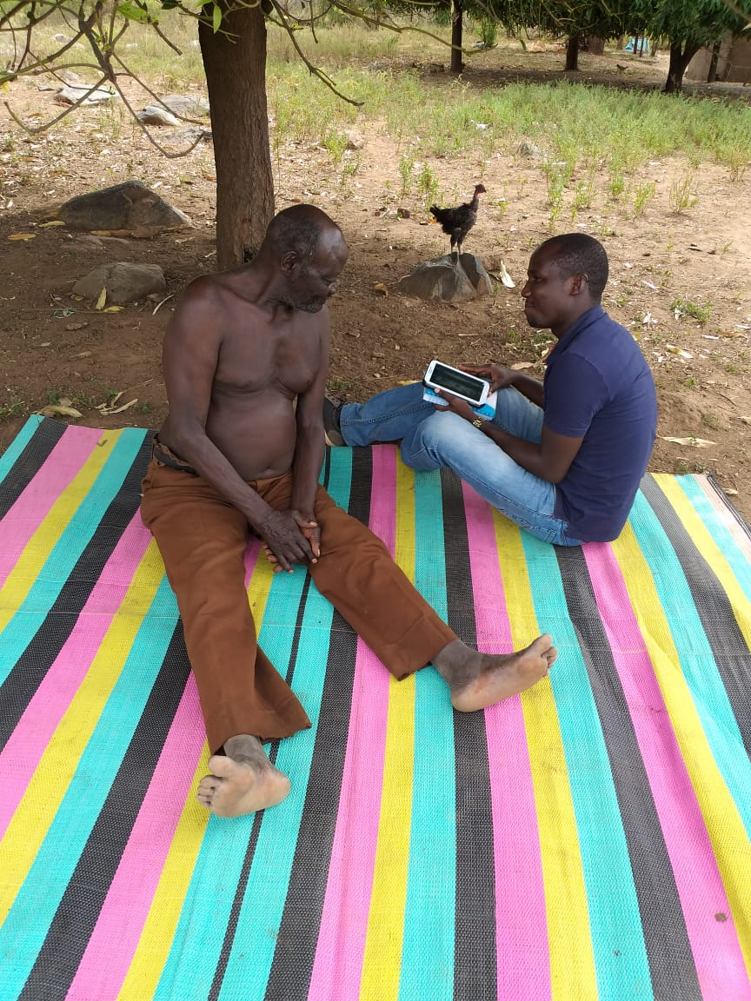
Administering Questionnare to a Respondent
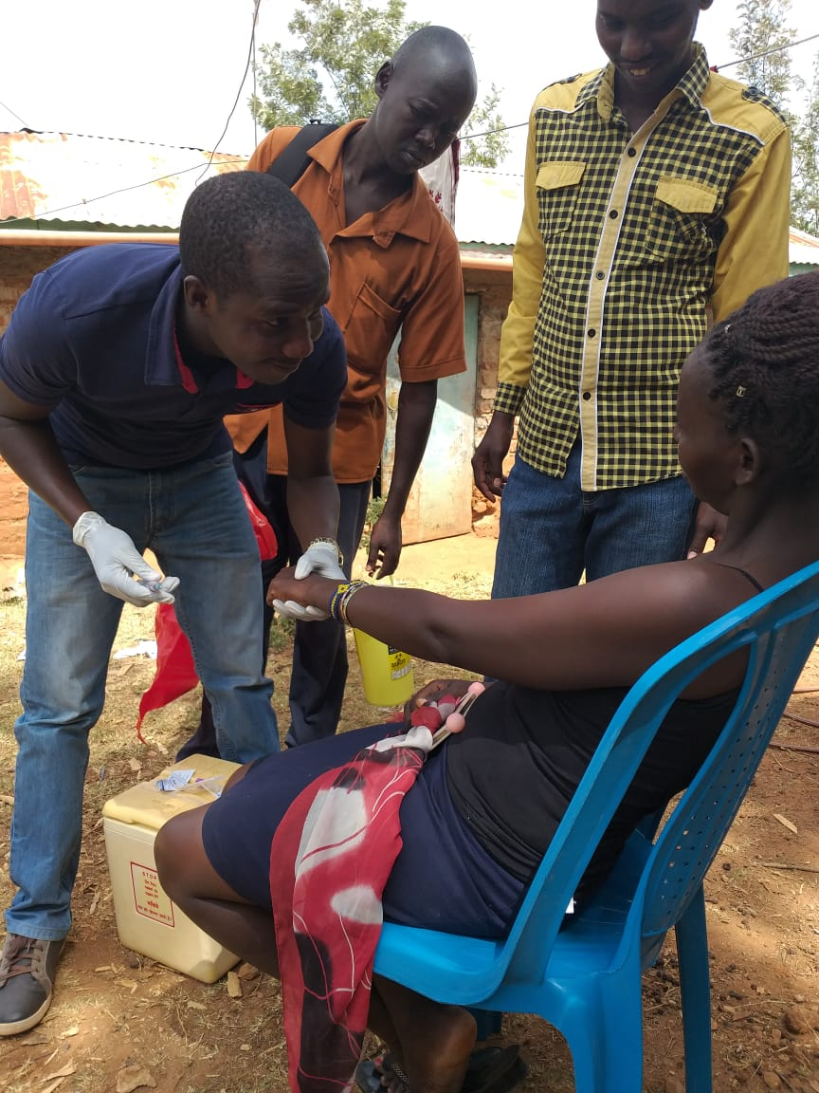
Taking Blood Samples at the community level
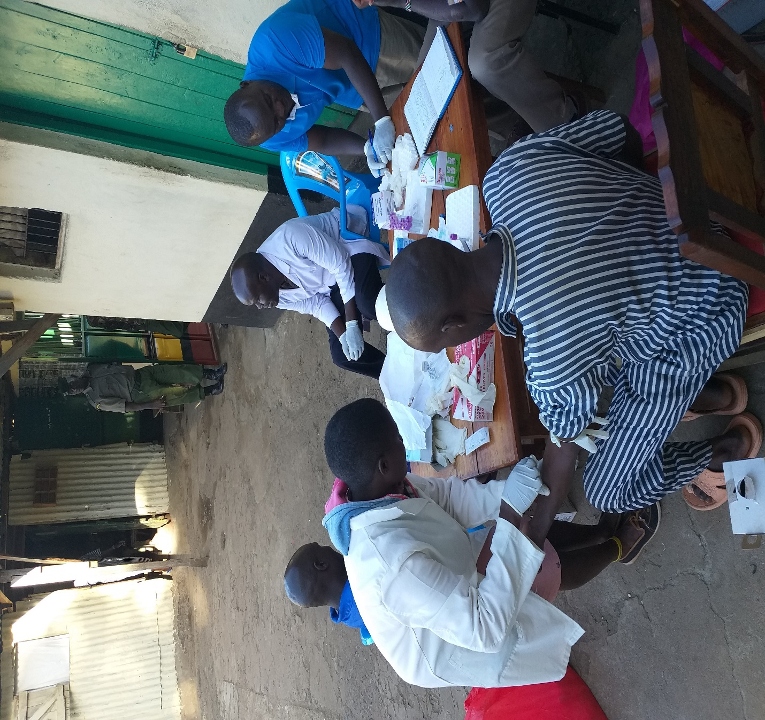
Taking Blood Sample from a Prisoner

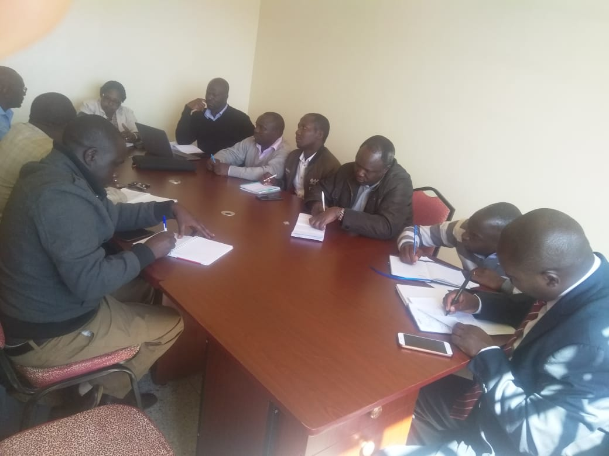
Dissemination Meeting with County Health Management Team

